UNIVERSIDADE FEDERAL DE JUIZ DE FORA
ARQUIVO CENTRAL

Fundo | Fórum Benjamin Colucci | 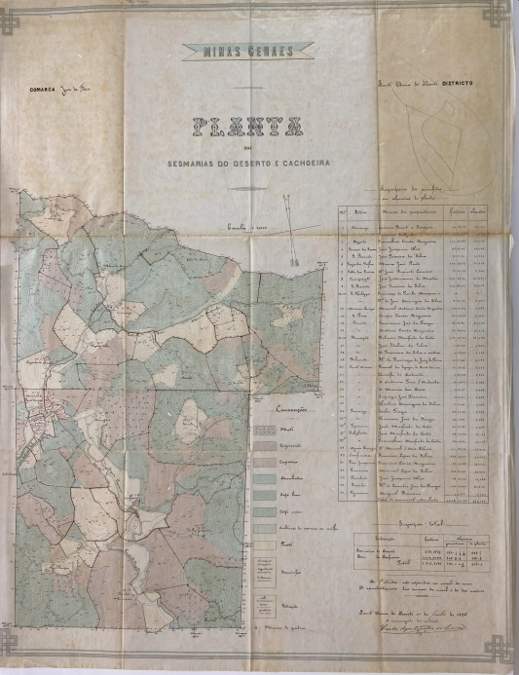  BR_MG_UFJF_AH_FFBC_CART_1895_01
Série | Divisão e Demarcação de Terras
Ano | 1895
Número | 02
Caixa | 13
Parte 1 | Antônio Manoel Tostes e outros
Parte 2 | Juizo de Direito
Obs 1 | Anexo: planta 01 fl. 18
Documento Cartográfico
Denominação | Planta das Sesmarias do Deserto e Cachoeira
Tipologia | Planta
Autor | Carlos Agostinho Arbarra (agrimensor)
Ano | 1895
Escala | 1:10.000 metros
Suporte | Tecido encerado
Descrição | Manuscrito, tinta nanquim e lápis de cor
Dimensões | Planta 1 – 94 x 61 cm
Identificação | Planta 1 – BR_MG_UFJF_AH_FFBC_CART_1895_01
Localização atual | Sala 12, Mapoteca 02, gaveta 01
Obs 2 | Distrito de Santana do Deserto

