UNIVERSIDADE FEDERAL DE JUIZ DE FORA
ARQUIVO CENTRAL

Fundo | Fórum Benjamin Colucci | 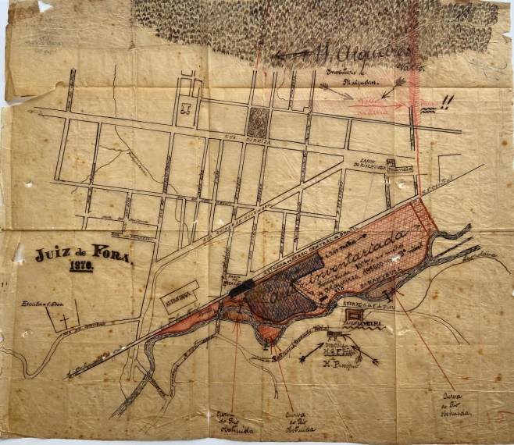  BR_MG_UFJF_AH_FFBC_CART_1870_01
Série | Divisão e Demarcação Urbana
Ano | 1935
Número | 01
Caixa | 03
Parte 1 | Doroteia Anna Halfeld (espólio de)
Parte 2 | Alfredo Ferreira Lage e outros
Obs 1 | Anexo: planta fl. 50
Documento Cartográfico
Denominação | Juiz de Fora
Tipologia | Planta
Autor | Peritos agrimensores (agrimensor)
Ano | 1870
Escala | 1:5.000 metros
Suporte | Papel de seda
Descrição | Manuscrito, colorido, tinta caneta
Dimensões | 38,0 x 44,0 cm
Identificação | BR_MG_UFJF_AH_FFBC_CART_1870_01
Localização atual | Sala 12, Mapoteca 02, gaveta 01
Obs 2 | Planta da região central de Juiz de Fora, área da Praça da Estação

