UNIVERSIDADE FEDERAL DE JUIZ DE FORA
ARQUIVO CENTRAL

Fundo | Fórum Benjamin Colucci | 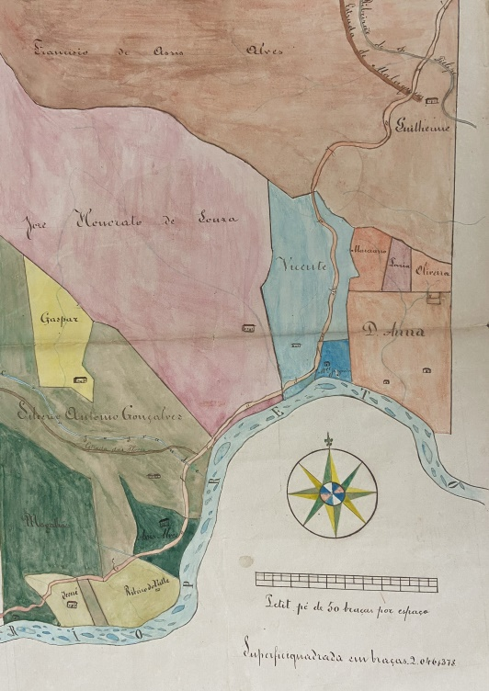  BR_MG_UFJF_AH_FFBC_CART_1864_01
Série | Divisão e Demarcação de Terras
Ano | 1864
Número | 01
Caixa | 01
Parte 1 | Francisco Ribeiro de Magalhães e outros
Parte 2 | José Rodrigues Alves Barbosa
Obs 1 | Anexo: desenho fl.7
Documento Cartográfico
Denominação
Tipologia | Desenho
Autor | Jacintho José Moniz (agrimensor)
Ano | 1864
Escala | 50 braças por espaço
Suporte | Papel
Descrição | Manuscrito, colorido, lápis de cor, tinta nanquim
Dimensões | 62,0 x 39,0 cm
Identificação | BR_MG_UFJF_AH_FFBC_CART_1864_01
Localização atual | Sala 12, Mapoteca 02, gaveta 01
Obs 2

