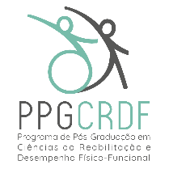

GRADUATE PROGRAM IN REHABILITATION SCIENCES AND PHYSICAL-FUNCTIONAL PERFORMANCE
N/N Eugênio do Nascimento, Juiz de Fora, MG 36038-330
Phone: +55 (32) 2102-3256
E-mail: mestrado.fisioterapia@ufjf.br; Website: www2.ufjf.br/ppgcrdf

DECLARATION OF AVAILABILITY TO FULFILL 20 HOURS WEEKLY OF ACTIVITIES IN THE PROGRAM

I declare that the information contained in the application form of candidates for the Master's Course of the Graduate Program in Rehabilitation Sciences and Physical-Functional Performance expresses the truth, as well as, I declare that I am able to attend the course, even though I am not awarded with a Scholarship. I declare that I am willing to dedicate at least 20 hours/week in person to academic-scientific activities for the postgraduate program, since the course is not an EAD modality (i.e., distance learning).
I would also like to add that I am aware of the rules established for carrying out the Selection Process and that the maximum period for preparing the dissertation defense is 24 (twenty-four) months.

Location and date:_____________________________

Signature: ________________________

