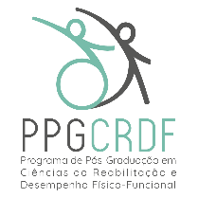
GRADUATE PROGRAM IN REHABILITATION SCIENCES AND PHYSICAL-FUNCTIONAL PERFORMANCE
N/N Eugênio do Nascimento, Juiz de Fora, MG 36038-330
Phone: +55 (32) 2102-3256
E-mail: mestrado.fisioterapia@ufjf.br; Website: www2.ufjf.br/ppgcrdf

SELF-DECLARATION TEMPLATE FOR CANDIDATES DECLARING THEMSELVES AS TRANS PEOPLE (TRANSEXUALS, TRANSGENDER, AND TRAVESTIS)

I, [Your Name], CPF No. [Your CPF], holder of identity document No. [Your ID], declare for the specific purpose of meeting the SELECTION NOTICE FOR ADMISSION TO THE MASTER'S COURSE in the year 2024, of the Graduate Program in REHABILITATION SCIENCES AND PHYSICAL-FUNCTIONAL PERFORMANCE, at the Federal University of Juiz de Fora, that I am a [transgender/transexual/travesti]. I am aware that if falsity is detected in this declaration, I will be subject to legal penalties.

Location and date:_____________________________

Signature: ________________________

